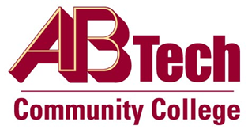

# Asheville-Buncombe Technical Community College (A-B Tech) Policy Manual

## Policy 818: Student Appeals

It is the policy of the Board of Trustees that students may appeal administrative actions or decisions which directly affect their educational experience.

## Scope

Applies to all A-B Tech students.

## Definitions

None

## References

Reviewed by the Executive Leadership Team, August 31, 2011.

Reviewed by the College Attorney, September 19, 2011.

Reviewed by the BOT of Trustees Executive Committee, September 22, 2011.

## Policy Owner

Vice President for Student Services, Ext. 7900

See Student Appeals Procedure

See Student Appeals Form

Approved by the Board of Trustees on November 7, 2011.